**Images on canvas**

**Please Test it after each step!**

Step 1:

Please define style for the canvas background:

<canvas id="myCanvas" width="600" height="400" style="background-image:url('sky.png');"></canvas>



Step 2: A**dd image to canvas using javascript:**

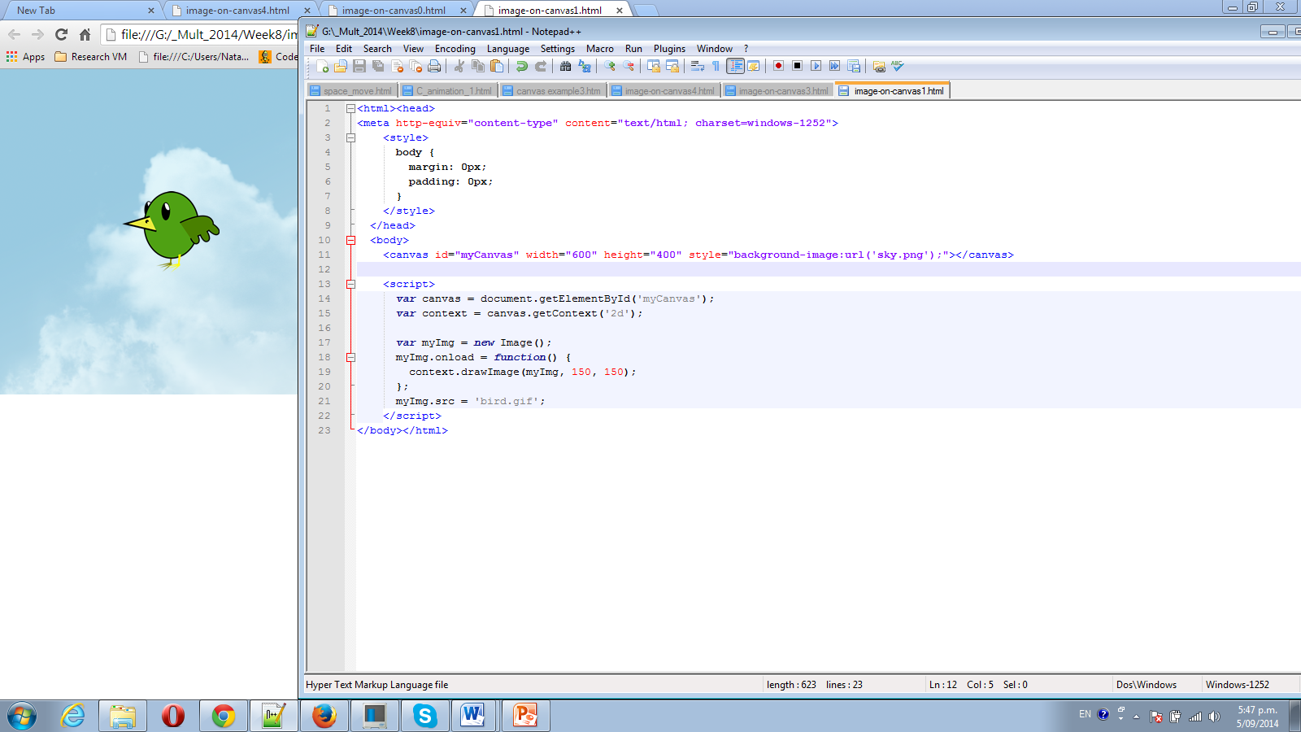

Step 3

We can draw on top of image as well.

Change on bigger “bird”

myImg.src = 'birdB.gif';

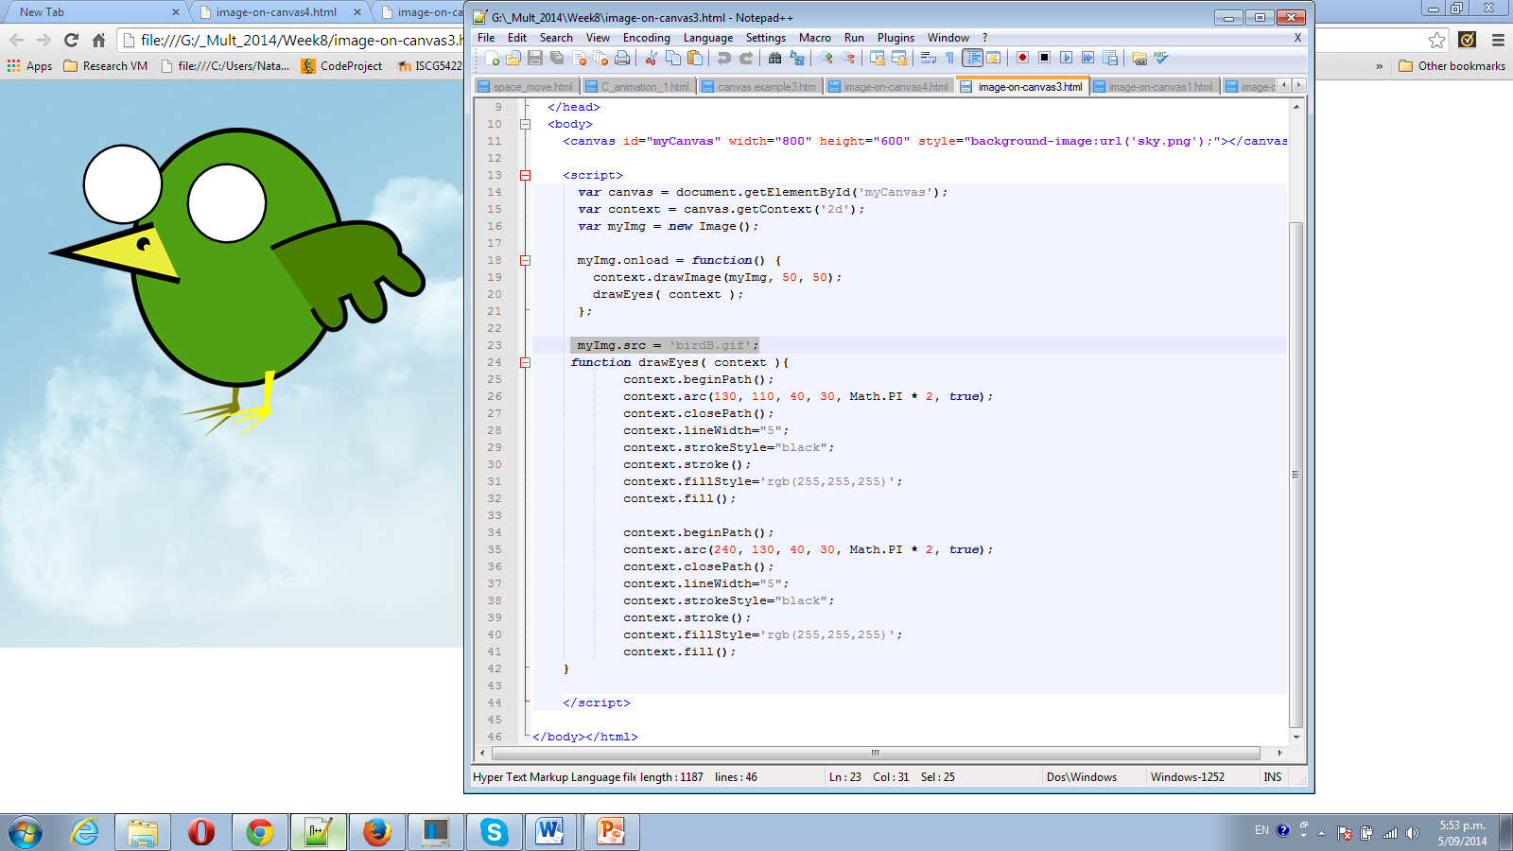

Step 4 Animate eyes as we do it.

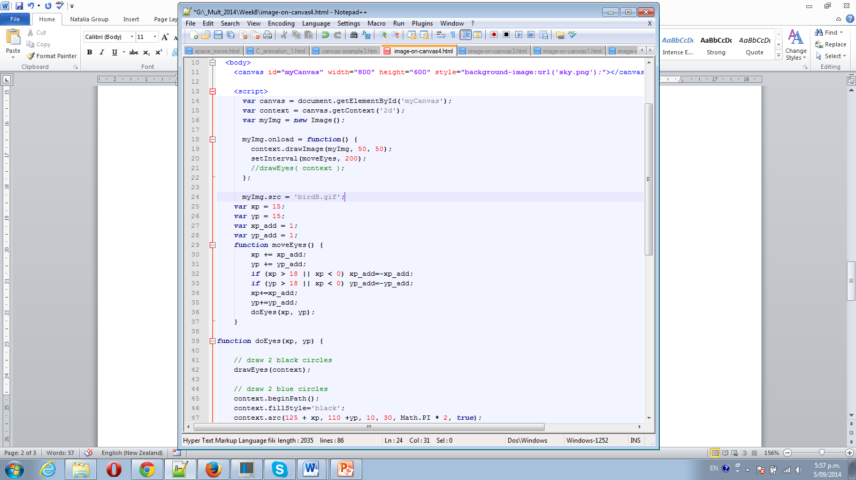

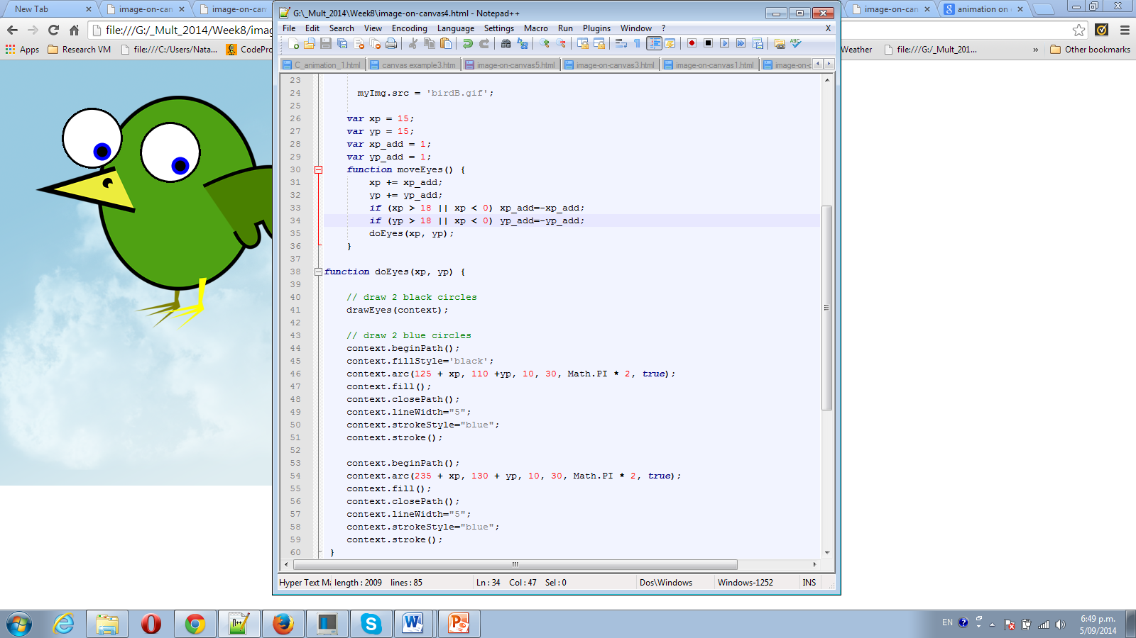

Step 5 move all birds image and keep animation for eyes.

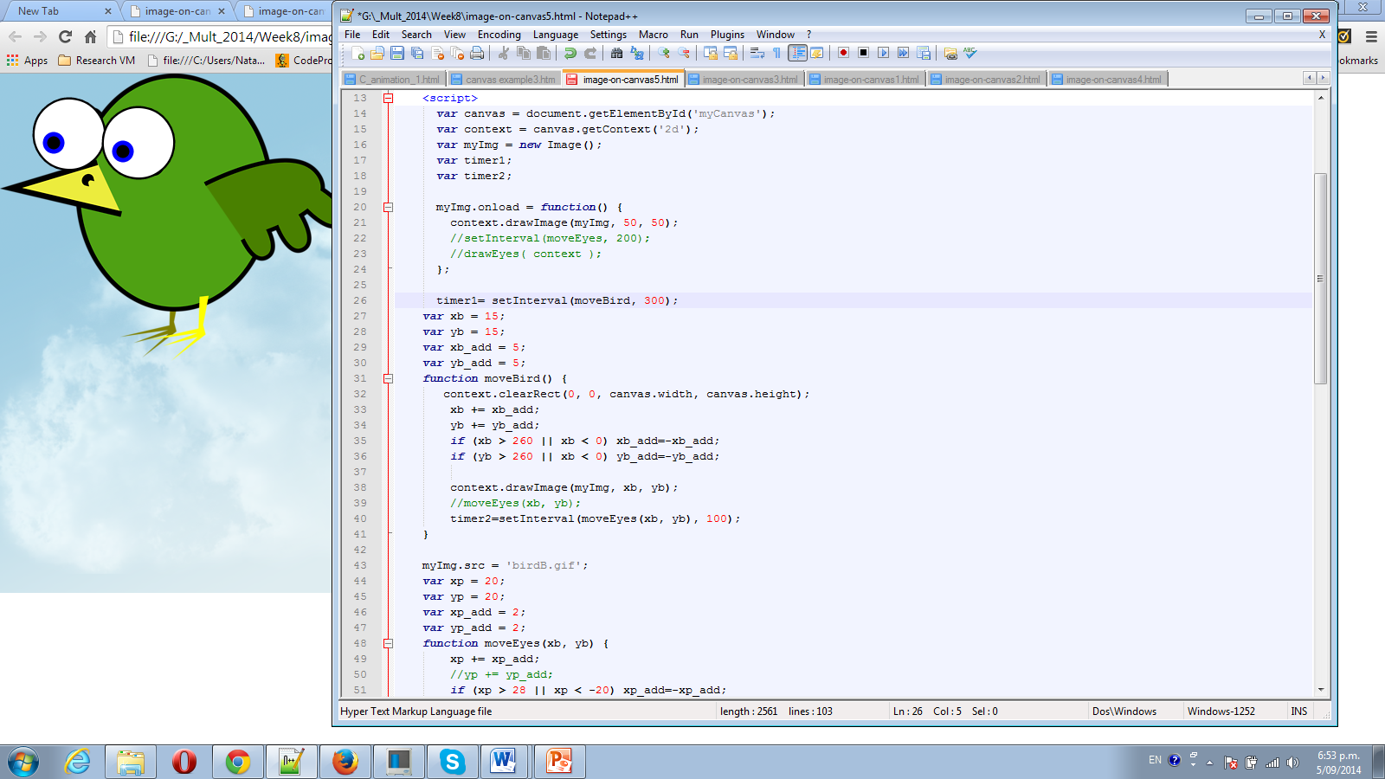

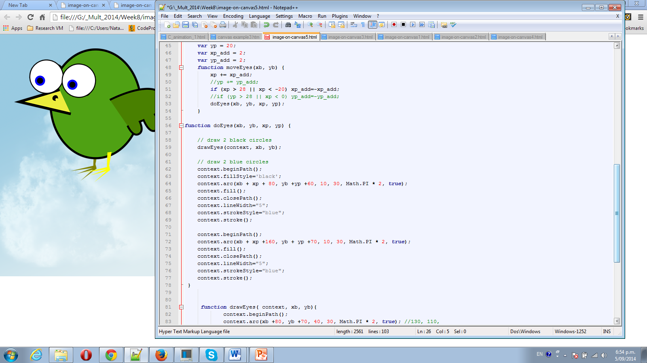

Step 6

Download folder “Family album”- Review and try it.

Ref: <http://faculty.purchase.edu/jeanine.meyer/collageApril2012.pdf>

Step 7 Look on example – “GraphSample” from folder “GraphSample”